Project Design Phase
Solution Architecture

Date | 20 February 2026
Team ID | LTVIP2026TMIDS65579
Project Name | Importing & Securing Data in ServiceNow
Maximum Marks | 4 Marks

Solution Architecture:
The solution architecture consists of importing bulk data into the ServiceNow platform using Import Sets and Transform Maps.
- Bulk data is uploaded into the system using Import Sets (CSV/Excel files).
- Transform Maps are used to map and convert source data into the target table.
- Role-based access control is implemented to manage user permissions in ServiceNow.
- Provide specifications according to which the solution is defined, managed, and delivered.

Example - Solution Architecture Diagram:

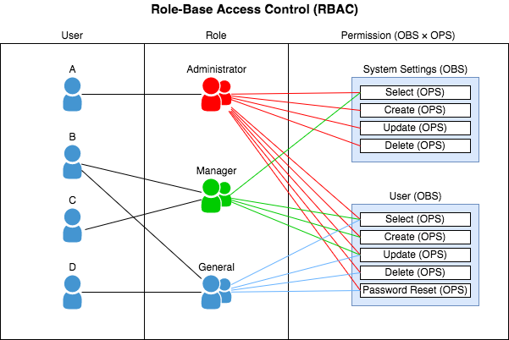
Figure 1: Architecture and data flow of the voice patient diary sample application

Reference: https://aws.amazon.com/blogs/industries/voice-applications-in-clinical-research-powered-by-ai-on-aws-part-1-architecture-and-design-considerations/

